## horizontal line

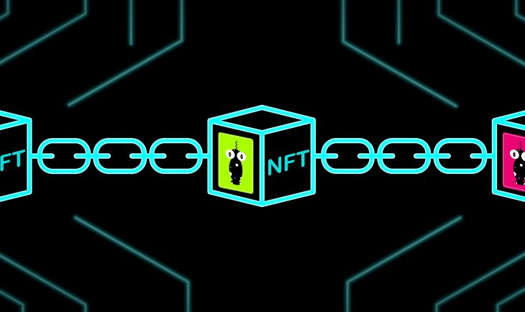

Project 3

Richie Garafola - Mark Staten - Jacob Edelbrock

07.26.2022

**─**

# Overview

Create a non transferable NFT that will allow users access to our application deployed on Streamlit Cloud. The application will provide a dashboard that users can interact with displaying useful day trading metrics and a forecast of asset prices. We will provide access to DOW 30 but can expand in the future if we decide to. We will collect the end users activity in the application and save activity to a SQL database for the purpose of future development and user behavior/activity research.

# Goals

Create a purposeful dashboard that will:

1. Forecast the daily closing price using time series models (example but not limited to Prophet and ARIMA)
2. Forecast the trend using a model ( Neural Network for example )

Using blockchain technology, create a non transferable NFT that will allow users secure access to our platform.(ERC1155 Standards, also known as “Semi-Fungible Token”)

Create mechanism for Minting NFT’s and/or transferring ownership to users wallet

Deploy platform using Streamlit Cloud

# Technologies used:

Streamlit (Dashboard) Dark Mode

Streamlit Cloud (Deploy)

Pandas (Dataframes)

Blockchain / NFT

3rd web - prebuilt contracts

Solidity (maybe)

SQL - postgres

## Abstract:

## ERC-1155 Multi Token Standard

This standard outlines a smart contract interface that can represent any number of fungible and non-fungible token types. Existing standards such as ERC-20 require deployment of separate contracts per token type. The ERC-721 standard’s token ID is a single non-fungible index and the group of these non-fungibles is deployed as a single contract with settings for the entire collection. In contrast, the ERC-1155 Multi Token Standard allows for each token ID to represent a new configurable token type, which may have its own metadata, supply and other attributes. [(https://eips.ethereum.org/EIPS/eip-1155)](https://eips.ethereum.org/EIPS/eip-1155))

**Streamlit Cloud:**

Streamlit Cloud is a workspace for your team to deploy, manage, and collaborate on your Streamlit apps. You connect your Streamlit Cloud account directly to your GitHub repository (public or private) and then Streamlit Cloud launches the apps directly from the code you've stored on GitHub. Most apps will launch in only a few minutes, and any time you update the code on GitHub, your app will automatically update for you. This creates a fast iteration cycle for your deployed apps, so that developers and viewers of apps can rapidly prototype, explore, and update apps.

Under the hood Streamlit Cloud handles all of the containerization, authentication, scaling, security and everything else so that all you need to worry about is creating the app. Maintaining Streamlit apps is easy. Containers get the latest security patches, are actively monitored for container health. We are also building the capability to observe and monitor apps. [(https://docs.streamlit.io/streamlit-cloud/get-started)](https://docs.streamlit.io/streamlit-cloud/get-started))